CUSTOMER REQUIREMENTS SPECIFICATION (CRS)
Name of Project: Electronic Device Helpdesk Support System (Bug Reporting Telecom Support System)
- Modeling requirements of customer (Use case Diagram)

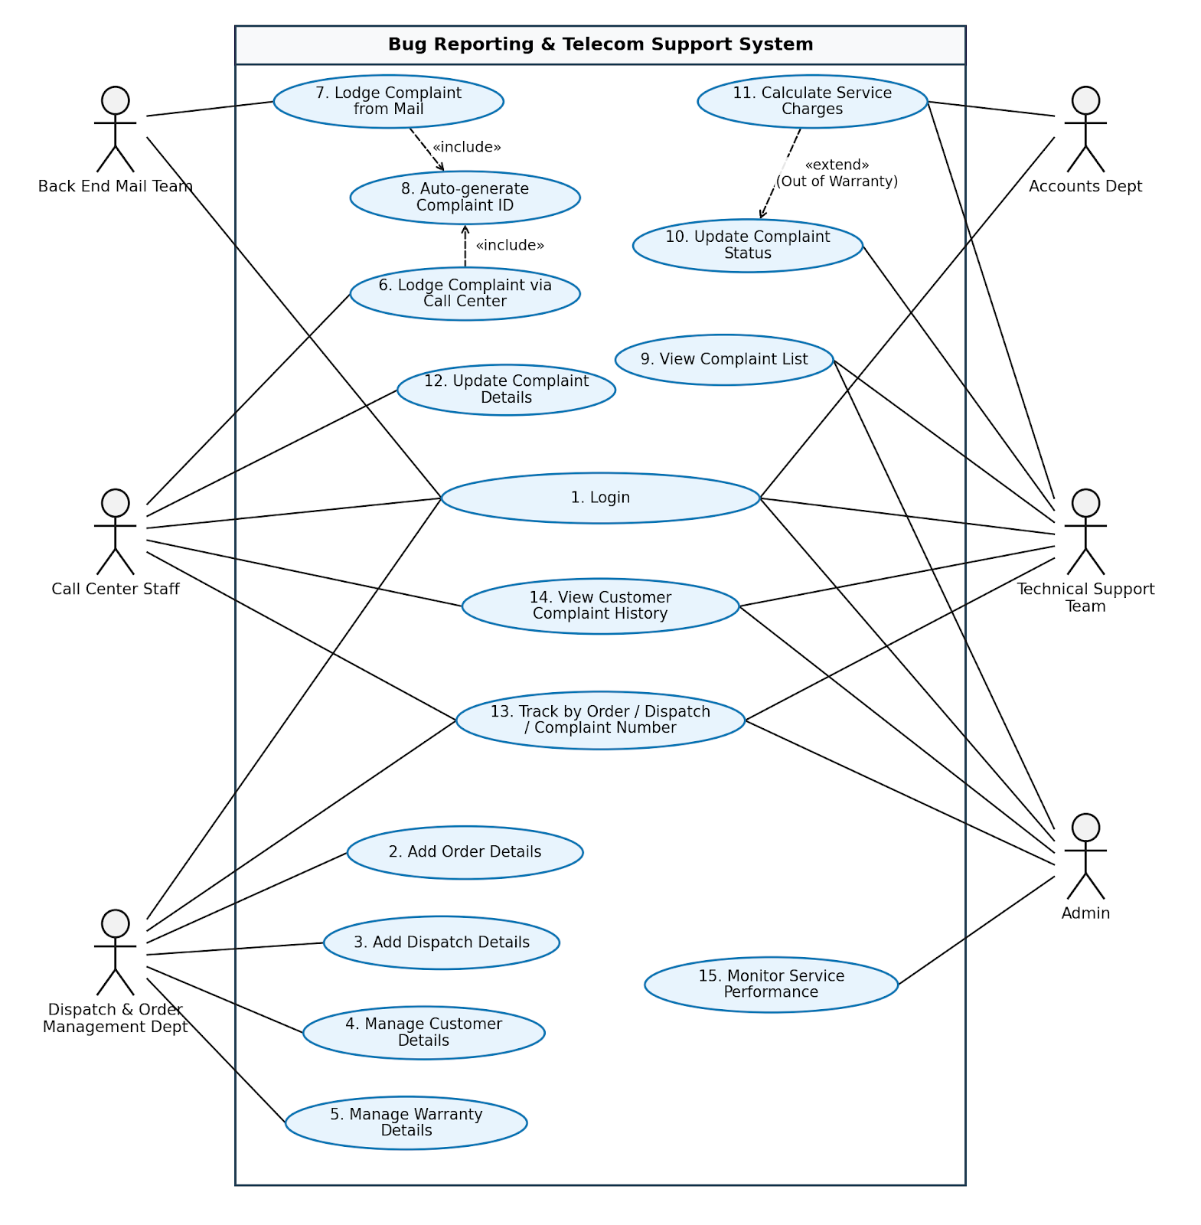
- Actor Description
No. | Actor | Use Case | Description
 | Admin | UC01. Login | Allows the Administrator to log into the system with full administrative privileges.
 | Admin | UC13. Track by Order / Dispatch / Complaint Number | Tracks customer details, order information, dispatch details, or complaint records using corresponding IDs.
 | Admin | UC14. View Customer Complaint History | Views all past complaints and reported issues logged by a specific customer.
 | Admin | UC09. View Complaint List | Views the complete list of all complaints registered in the system to date.
 | Admin | UC15. Monitor Service Performance | Tracks complaint frequency and measures the resolution time and performance of support staff in serving customers.
 | Dispatch & Order Management Department | UC01. Login | Allows Dispatch and Order Management department personnel to log into the system.
 | Dispatch & Order Management Department | UC02. Add Order Details | Adds and stores detailed information about new telecom product orders placed by customers.
 | Dispatch & Order Management Department | UC03. Add Dispatch Details | Adds dispatch records and generates a unique dispatch number (Dispatch No.) specific to each order.
 | Dispatch & Order Management Department | UC04. Manage Customer Details | Creates, stores, and updates customer profile details.
 | Dispatch & Order Management Department | UC05. Manage Warranty Details | Defines and stores product warranty terms and durations based on the specific dispatch and product type.
 | Dispatch & Order Management Department | UC13. Track by Order / Dispatch Number | Searches and tracks customer and order details using order numbers or dispatch numbers.
3 | Call Center Staff | UC01. Login | Allows Front End call center employees to log into the system.
3 | Call Center Staff | UC13. Track by Order / Dispatch / Complaint Number | Tracks customer information and complaint status using order numbers, dispatch numbers, or complaint IDs.
3 | Call Center Staff | UC14. View Customer Complaint History | Checks the complete history of all complaints previously logged by a customer.
3 | Call Center Staff | UC06. Lodge Complaint via Call Center | Receives complaint calls from customers and logs new complaint tickets into the application.
3 | Call Center Staff | UC10. Update Complaint Details | Updates or adds details to an existing complaint record (System rule: Deletion of complaints is strictly prohibited).
4 | Technical Support Team | UC01. Login | Allows Back End technical support engineers to log into the system.
4 | Technical Support Team | UC13. Track by Order / Dispatch / Complaint Number | Tracks issue details and customer equipment records using unique identifiers.
4 | Technical Support Team | UC09. View Complaint List | Checks the list of all complaints logged in the system requiring service or already serviced.
4 | Technical Support Team | UC14. View Customer Complaint History | Reviews prior service/fault history of a customer or device to facilitate repair work.
4 | Technical Support Team | UC10. Update Complaint Status | Changes the status of a complaint (e.g., Pending, In Progress, Resolved) based on the service provided.
4 | Technical Support Team | UC11. Calculate Service Charges | Calculates and records repair charges if the product is out of warranty or if a valid warranty card is not presented.
5 | Back End Mail Team | UC01. Login | Allows email support team staff to log into the system.
5 | Back End Mail Team | UC07. Lodge Complaint from Mail | Processes emails received at helpdesk@tele-comsupport.com and logs them directly as new complaints in the application.
6 | Accounts Department | UC01. Login | Allows Accounts department personnel to log into the system to access authorized financial and billing records.

- Use case Description
  - Authentication & Role Management : This module allows all authorized system actors (Admin, Dispatch & Order Dept, Call Center Staff, Technical Support Team, Back End Mail Team, and Accounts Dept) to log into the application with role-based access control.
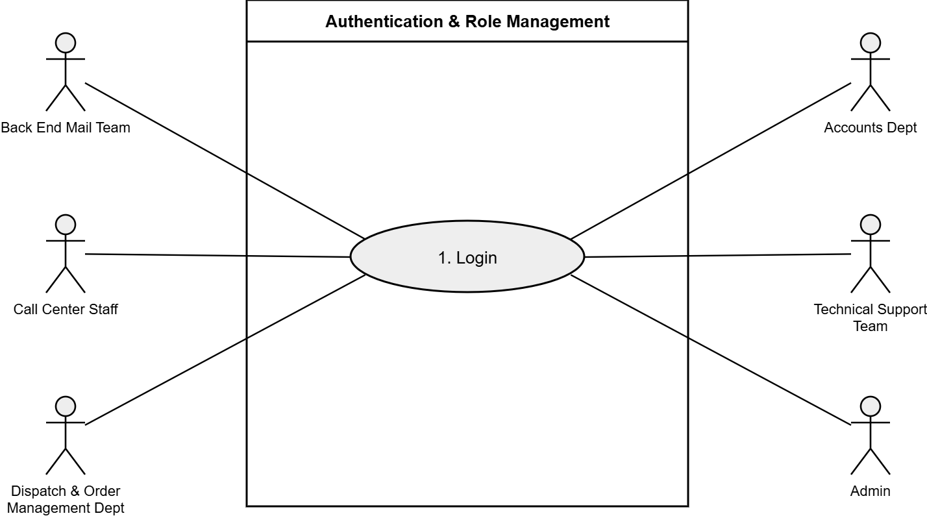
    - (UC 01) Login
- Purpose: Authenticates user credentials and grants system privileges according to the user's department role.
- Inputs: Username, Password, Selected Role (Admin, Dispatch, Call Center, Tech Support, Mail Team, Accounts).
- Outputs: Valid session granted and user redirected to role dashboard, or error message displayed for invalid credentials.

  - Order & Warranty Management: This module allows the Dispatch and Order Management Department to create and manage records for customer orders, dispatch dispatches, customer profiles, and product warranty terms.
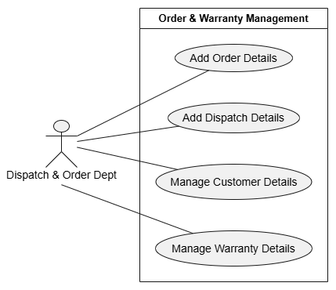
3.2.1.(UC 02) Add Order Details
- Purpose: Allows staff to log new orders placed by customers for telecom products.
- Inputs:Order Number, Customer ID, Product ID, Product Quantity, Order Date.
- Outputs:Order record successfully saved to the database.
3.2.2.(UC 03) Add Dispatch Details
- Purpose: Creates a dispatch entry and assigns a specific Dispatch Number linked to an existing order.
- Inputs: Dispatch Number, Order Number, Shipping Date, Delivery Address.
- Outputs: Dispatch record stored in database and linked to the Order Number.
3.2.3.(UC 04) Manage Customer Details
- Purpose: Creates and updates profile information for customers ordering telecom products.
- Inputs: Customer ID, Name, Phone Number, Email Address, Billing/Shipping Address.
- Outputs: Customer profile created or updated in the database.

3.2.4.(UC 05) Manage Warranty Details
- Purpose: Defines and stores product warranty terms and validity periods specific to product types in a given dispatch.
- Inputs: Product ID, Dispatch Number, Warranty Duration (months/years), Warranty Start/End Date, Policy Terms.
- Outputs: Warranty details stored and linked to product dispatch record.

3.3.Complaint Logging & Management: This module enables Call Center Staff and the Back End Mail Team to capture customer issue reports, automatically generate sequential IDs, and update complaint notes.
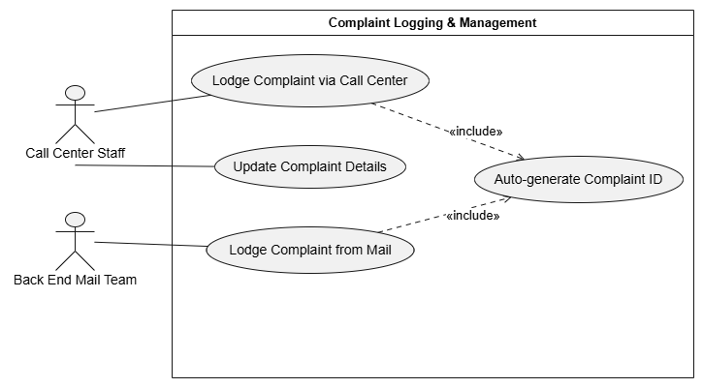
3.3.1.(UC 06) Lodge Complaint via Call Center
- Purpose: Allows front-end call center staff to log issue reports phoned in by customers.
- Inputs: Order Number or Dispatch Number, Customer ID, Fault Description, Telecom Product Type.
- Outputs: New complaint ticket created and saved in the system.
3.3.2.(UC 07) Lodge Complaint from Mail
- Purpose: Allows the back-end email team to process emails sent to helpdesk@tele-comsupport.com and log them into the application.
- Inputs: Sender Email Address, Email Subject, Email Body/Fault Description, Order/Dispatch Number (if provided).
- Outputs: New complaint ticket logged from email source.
3.3.3.(UC 08) Auto-generate Complaint ID
- Purpose: System sub-routine that automatically generates a unique, sequential complaint ID upon ticket creation.
- Inputs: Internal system trigger from complaint creation.
- Outputs: Sequential Complaint ID generated (e.g., CMP-00001).
3.3.4.(UC 12) Update Complaint Details
- Purpose: Allows staff to update or append notes to an existing complaint (Deletion of complaints is prohibited by system rules).
- Inputs: Complaint ID, Additional Fault Details, Customer Notes.
- Outputs: Complaint details updated in database.
3.4. Technical Support & Service Processing:This module allows the Back End Technical Support Team to review complaint queues, update resolution statuses, and calculate repair charges for out-of-warranty services.
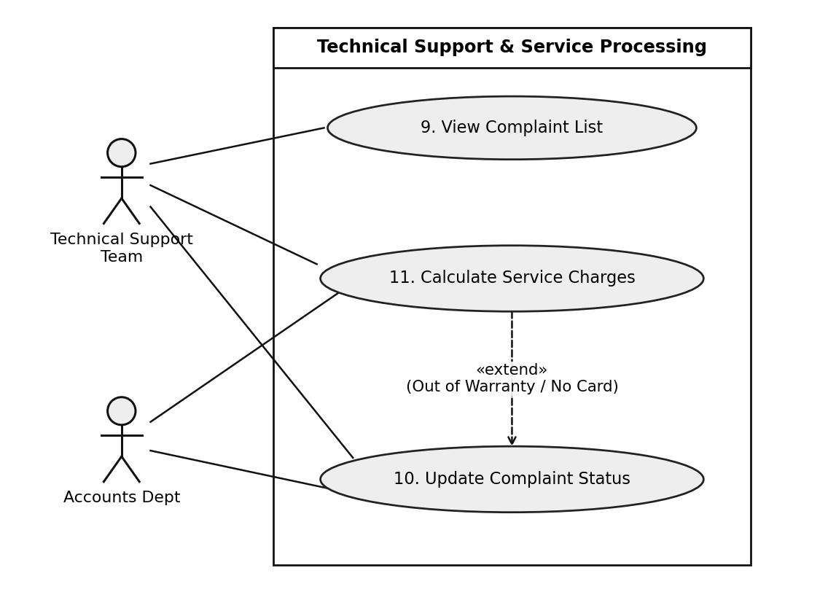

3.4.1.(UC 09) View Complaint List
- Purpose: Allows Technical Support Team and Admin to view the complete list of all complaints registered in the system till date requiring service or already serviced.
- Inputs:Filter Criteria (Complaint Status, Date Range, Product Type, Assigned Technician).
- Outputs: Display list of complaint tickets logged to date.
3.4.2.(UC 10) Update Complaint Status
- Purpose: Allows Back End Technical Support Team engineers to assign technicians and change the status of a complaint (e.g., Pending, In Progress, Resolved, Closed) based on the service provided.
- Inputs: Complaint ID, Assigned Technician, New Status, Service Resolution Notes, Work Date.
- Outputs: Complaint status updated in the database.
3.4.3.(UC 11) Calculate Service Charges
- Purpose: Calculates repair fees if the fault occurred outside the warranty period or if no valid warranty card was presented as proof.
- Inputs: Complaint ID, Fault Category, Warranty Card Presentation Status (Present/Missing), Part Replacement Costs, Labor Fee.
- Outputs: Calculated service charge appended to the complaint service bill.

3.5.Tracking & Performance Monitoring: This module allows system users to search records by order, dispatch, or complaint IDs, view historical complaints, and enables Admin to measure staff service metrics.
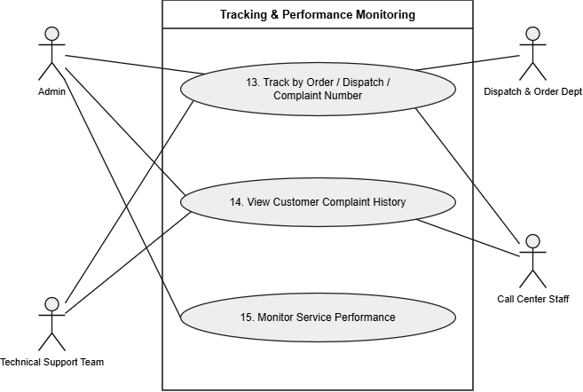

3.5.1.(UC 13) Track by Order / Dispatch / Complaint Number
- Purpose: Allows Admin, Dispatch & Order Management Dept, Call Center Staff, and Technical Support Team to track customer details, order information, dispatch details, or complaint records using Order Number, Dispatch Number, or Complaint Number.
- Inputs: Order Number OR Dispatch Number OR Complaint Number (Complaint ID).
- Outputs: Complete record displaying customer details, order info, dispatch date, and warranty status.

3.5.2.(UC 14) View Customer Complaint History
- Purpose: Allows Admin, Call Center Staff, and Technical Support Team to view the complete chronological history of all complaints lodged till date whenever customer detail record is accessed.
- Inputs: Customer ID, Phone Number, or Email.
- Outputs: Chronological list of past complaints logged by the customer.
3.5.3.(UC 15) Monitor Service Performance
- Purpose: Enables the Admin to check complaint details, track how often complaints occur, and measure how much time staff take to service customers (via interactive charts &amp; Excel exports).
- Inputs: Date Range, Department / Support Team Filter, Product Category.
- Outputs: Performance metrics report displaying total cases handled, average resolution time, and pending ticket status.

- Hardware and Software required for implementing the project
 | Server | Client
Hardware | • Processor: Pentium 166 MHz or higher (Pentium IV or higher recommended)  • RAM: 128 MB or higher (256 MB recommended)  • Hard Disk Space: 2 GB available space or higher | • Processor: Pentium 166 MHz or better  • RAM: 64 Megabytes of RAM or better  • Hard Disk Space: 500 MB available space
Software | • Operating System: Windows 98 / Windows 2000 / Windows XP or higher  • Development Kit: JDK 1.4.1_02 (or later) / .NET  • Database Management: SQL Server 2000 (or later) / Oracle 9i / MS Access  • Web/Application Server: Apache Tomcat / WebLogic / IIS | • Operating System: Windows 98 or higher  • Runtime Environment: Java Virtual Machine (JVM)  • Editor / IDE: Notepad / Java Editor / NetBeans  • Web Browser: Internet Explorer / Mozilla Firefox / Google Chrome
Additional  Technology | • Web Component Technologies: JSP / Servlets  • Enterprise / Framework: EJB / Struts  • Database Connectivity: JDBC & JDBC Drivers

